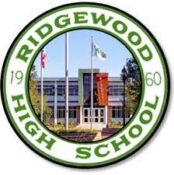
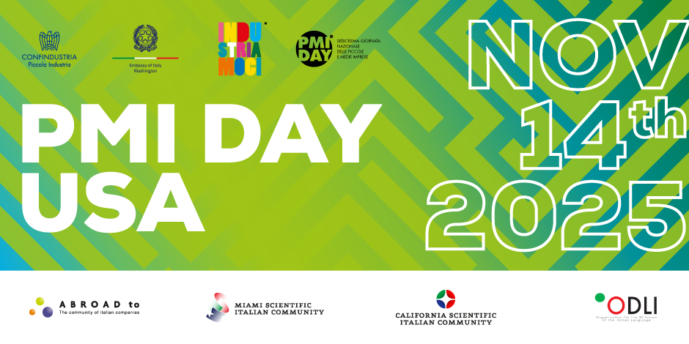
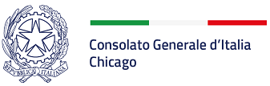

PMI Day – The 16th National Day of Small and Medium-Sized Italian Companies in the USA
Wednesday, November 19th, 2025

MARIO ALBERTO BARTOLI, Consul General of Italy in Chicago, is proud to celebrate the 16th edition of the PMI Day, the Day of Italian Small and Medium-Sized Italian Companies in the USA. During the PMI Days, Italian entrepreneurs and executives of Small and Medium-Sized Italian Companies based in the US meet American students and engage them on the vision and the mission of the companies they lead, as well as the values and the quest for continuous innovation that Italian small and medium companies traditionally embrace.
The theme of choice for the 2025 edition of the PMI Day is “Scegliere” – the right and duty to chose one’s personal and professional path towards the future, through education and dialogue with all the relevant stakeholders in the social, cultural and economic ecosystems in our society.
The event will take place on Monday, Nov. 19th and it will be kindly hosted by the RIDGEWOOD HIGH SCHOOL, in Norridge, IL, with a presentation by Mr Stefano Comastri, General Manager of IEMA USA Inc, who will attend the meeting in person.
IEMA US, founded in 2016 and headquartered in Park Ridge, specializes in mechatronic software and artificial intelligence solutions aimed at enhancing manufacturing capabilities. It provides system integration, industrial automation, programming and development, and technical assistance services. Backed by over 20 years of IEMA Group expertise, the Company supports North American manufacturers with tailored services that ensure operational continuity and seamless integration with modern technologies, turning obsolescence into performance with revamping solutions.
Mr Comastri will introduce the company and share with the students its history, the business development in the US and its ambitions and aspirations for the future.

The presentation will take place in English and Italian with materials, videos, slides.

PROGRAM : 19.11.2025

11:00 AM CT Welcoming Remarks

11:05 AM CT Opening Remarks

Prof. Marina LENZA, Consulate General Italy Chicago, Education Office

Prof.ssa Dolores MILLER PIGONI, RIDGEWOOD HIGH SCHOOL

11:10 – 11:40 AM CT Entrepreneurship Panel

Engineer Stefano COMASTRI

11:40 – 11:45 AM CT Questions from students, audience

__________________________________________________________________________

Conso Chicago



